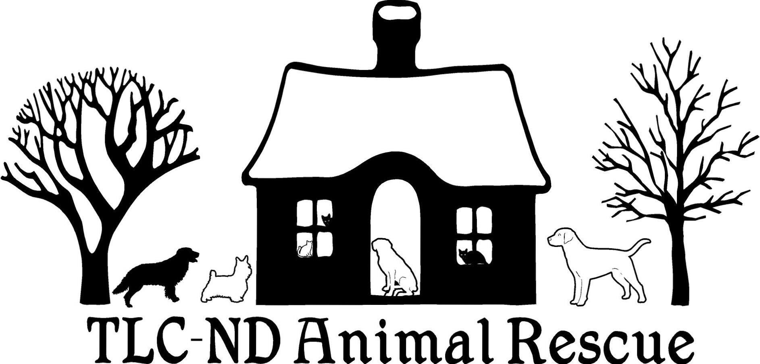

DOG FOSTERING HOME APPLICATION

Please e-mail completed application to tlcnd@gondtc.com or drop off in person at Tractor Supply Company in Devils Lake, ND -- they will contact me via telephone.
TLC-ND Animal Rescue
P.O. Box 1132
Devils Lake, ND 58301
701.662.4357, tlcnd@gondtc.com
On Facebook as "The Lil Cottage - ND Animal Rescue"
tlcndanimalrescue.com
Please note: Fostering a dog for TLC-ND Animal Rescue is a serious commitment and the rescue cannot give you a guaranteed time as to how long the dog will need to be fostered. If you want to be a temporary or emergency foster home (and not a long-term one) PLEASE INDICATE THAT BELOW.
____ I am interested in fostering a dog for a temporary/emergency period of time (SHORT-TERM) and can commit to a period of _______________.
____ I am interested in long-term fostering of the dog in question until such time that it is adopted into a forever home.
____ I understand that long-term fostering may require months of care and will be in consistent communication with the rescue during this time. N/A for short-term fosters.
Not everyone can foster dogs for an indefinite period of time and that is understandable. Some dogs are placed within a few weeks and some are in foster care until they are adopted which can be as long as nearly a year or more later. If you are unable to continue fostering, please contact 701.662.4357 as soon as possible, so that arrangements can be made in a timely matter to remove the dog from your home. Ongoing communication is crucial during the fostering process.
THE DOG YOU ARE INTERESTED IN ADOPTING OR FOSTERING IS:

_________________________________________

If there is no specific dog in the rescue currently, please indicate the size, sex and temperament of dog you are most comfortable fostering. _________________________________________________________________________________________________________________________________________________________________________________
1. Name:
2. Address, City, State, Zip Code:
3. Telephone: (cell), (home)
4. E-MAIL:
5. BEST WAY AND TIME TO CONTACT:
6. OCCUPATION and EMPLOYER's Name, Address and Telephone:
7. Your Age:
8. What type of home do you live in?
9. Do you have a fenced in yard? Yes or No
If so, what are the fence specifics? (materials, height, how big of an area)
10. Do you rent or own your own home? (if renting, written permission must be shown indicating that a dog is allowed)
10a. If renting, what is your landlord's name and telephone number?
11. 1st PERSONAL REFERENCE NAME, TELEPHONE and E-MAIL (please list best way to reach first):
12. 2nd PERSONAL REFERENCE NAME, TELEPHONE and E-MAIL (please list best way to reach first):
13. EMERGENCY CONTACT PERSON (relative most likely) that I can reach if you are not available: ________________________________
14. VETERINARIAN REFERENCE:
14a. VETERINARY RECORDS ARE UNDER WHAT NAME?
15. HOW MANY PEOPLE LIVE IN YOUR HOME?
16. NUMBER OF PEOPLE UNDER 21:
16a. LIST OF CHILDREN UNDER 21:
17. ANYONE LIVING IN HOME HAVE ALLERGIES?
18. Are all members of the household in favor of fostering a dog for TLC-ND Animal Rescue?
18a. If anyone is not in favor of fostering, who is that person and what is their reason?
DO NOT FILL OUT THE REST OF THE APPLICATION IF ANYONE IN THE HOME HAS AN ALLERGY TO DOGS OR IS NOT IN FAVOR OF FOSTERING. THANK YOU FOR YOUR INTEREST.
19. How long have you been interested in fostering a dog?
20. Why do you want to foster a dog at this time?
21. What is it about the dog you're interested in that appeals to you?
22. Are you able to transport the foster dog to veterinary appointments? Yes or No
Note: TLC-ND Animal Rescue pays for all veterinary costs while dogs or cats are being fostered.
23. Are you comfortable obtaining a stool sample from your foster dog (should one need to be dropped off at the veterinary clinic)?
24. Do you agree to have a collar with tags worn by the foster dog at all times (other than when they are in crate or kennel situation)? Yes or No
25. Do you have pets living in your home now? Yes or No
25a. Please list along with names and ages {cat(s) or dog(s)}
26. Do you have any pets that live outside 24/7?
26a. What type of pets are these (ages, sex, dog or cat, general health)?
26b. ARE ALL OF YOUR PETS CURRENT ON THEIR VACCINATIONS? Yes or No
26c. ARE ALL OF YOUR PETS SPAYED OR NEUTERED? Yes or No
If your answer is no, why is that?
26d. Anything else you'd like to add regarding your current pets (personality type, ongoing health concerns, etc.)?
27. If applicable, how does your dog react to other dogs?
27a. If applicable, how does your cat react to dogs?
28. Have you ever given away, sold, abandoned, surrendered or had a pet put to sleep?
28a. Please explain the situation if you answered yes to question #28.
29. Has any pet disappeared, been killed or injured, or mistreated while in your care?
29a. If yes, please explain the situation.
30. Explain conditions or circumstances that would cause you to give up any pet.
31. Have you fostered a pet before?
31a. If yes, through whom?
32. Do you allow pets on your furniture? Yes or No Explain.
33. What if the dog chews belongings or shows destructive behavior, what action would you take to correct?
34. Where will the foster dog be when all have left the house? Confined at all?

35. What is the longest amount of time that the foster dog will be left alone? Please explain.
36. Where will the foster dog sleep? Please explain.
37. Where will the foster dog be exercised and how often? What type of exercise?
37a. Who is primarily going to be responsible for making sure the foster dog gets plenty of physical activity and attention?
38. When and where will the foster dog be allowed off leash?
39. Are you willing to work with the foster dog on any issues? How comfortable are you working on training the foster dog? How would you describe your training style?
40. How long do you feel pets need for an adjustment period when they are newly placed in an adoptive or foster home?
41. Are you willing to allow a home visit? Yes or No
**A home visit takes approximately 30 minutes of your time and is a visit at your residence to meet all people who live in the home, along with any pets, to determine that you are going to provide a safe and loving home for the dog that you are applying to adopt or foster.
42. Have you answered all questions truthfully and honestly?
43. How did you hear about this dog being available for adoption, fostering and/or rehoming?
44. Today's date:
*Please note that any discrepancies in information shared with TLC-ND Animal Rescue by the prospective adopter or foster home that is discovered during the application process WILL result in an automatic denial to adopt or foster from TLC-ND Animal Rescue.

For office use only
Subject:

WARNINGS:

